**To Be A Transformational Leader, You Don’t Always Need To Be Innovative, You Just Need To Be Emotionally Intelligent!**

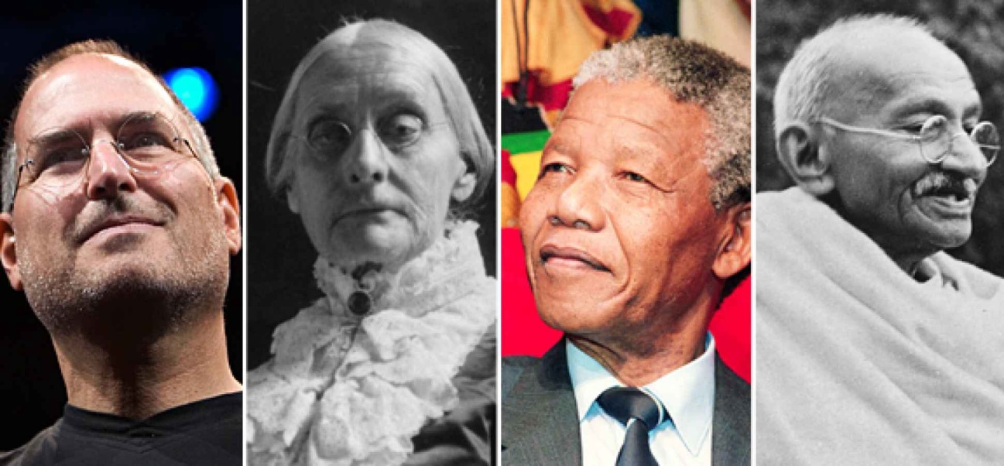

As an entrepreneur & a leader of a small troop who are hustling it with a strong sense of purpose

**I Strongly Feel:**

*To be a leader who champions change, you necessarily, need not be an innovator, you just need to be a facilitator who often engages with the team and not disengage & dictate.*

**Any organization small or big which is trying to adapt to the changing market dynamics need a very strong transformational leaders.**

A change leaders are not only open to new values and new ideas of change, but also understands that to get these new changes implemented, they need to first arouse the change within the people from the core. Traditional Management practices of rewarding and promoting hardly works well, when company is riding the wave of change.

These companies don’t needs innovators they need a mindful and inspiring leader who knows to manage their own emotions and the emotions of the people whom they are working with, exceptionally well. They know how to work with diverse set of people and give them a strong sense of purpose to be followed inclusively. They leverage the diversity to properly channelize the task and make people feel more accountable and responsible.

Now it becomes important that we first try to understand What actually **Transformational Leadership** is all about? & What are the traits of these kind leaders of change ?

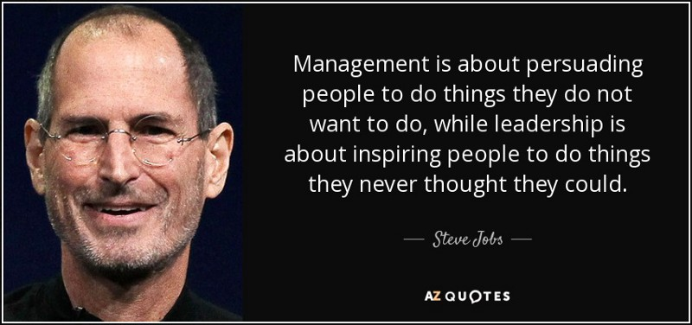

**What Do We Mean By Transformational Leadership ?**

In one of my friends company everyone has a high regard for Rahul as a leader(Name Changed), they love to work with him and are extremely loyal to him, Rahul leads a team of 5 people from various backgrounds and this team is called the champ within an organization, they are highly result oriented and successful as a unit.

In comparison to Rahul, Other leaders from a different department, reports frequently to the management about how their team members are often disengaged and are not able to delegate their task as per their instruction, These group of people are having no sense of purpose and clear cut direction to perform, result high attritions and lowered performance.

**Why do you think Rahul has been so successful even though at organizational level all work in the same company**? Well Its is because Rahul Is a Leaders Of Change and that is what we will uncover together as we proceed.

**Transformational Leadership :**

As Per Wiki,

*A style of leadership where a leader works with subordinates to identify needed change, creating a vision to guide the change through inspiration, and executing the change in tandem with committed members of a group.*

The very first time this term was coined by James V. Downton, which was enhanced by developed by leadership expert and presidential biographer[James MacGregor Burns](https://en.wikipedia.org/wiki/James_MacGregor_Burns), according to **Burns**,

*“ Transformational leadership can be seen when “leaders and followers make each other advance to a higher level of morality and motivation.” Through the strength of their vision and personality, transformational leaders are able to inspire followers to change expectations, perceptions, and motivations to work towards common goals. Unlike in the transactional approach, it is not based on a “give and take” relationship, but on the leader’s personality, traits and ability to make a change through example, articulation of an energizing vision and challenging goals.”*

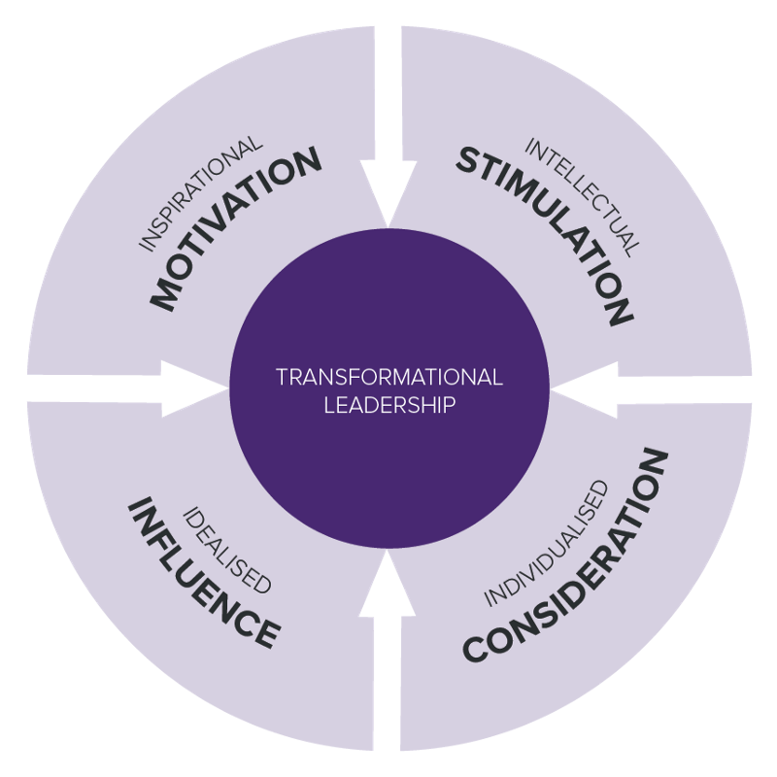

**The 4 I’s Of Transformational Leadership :**

* **II : Idealized Influence-**The leader with this kind of influence “ walk the talk “. People within an organization Idealize him as a role model and follows him blindly
* **IM : Inspirational Motivation-**Leaders of a change have this astute ability to inspire and motivate their troop. Combined these first two I’s (II+IM) are what makes a leader truly charismatic and powerful.
* **IC : Individualized Consideration (Empathy)-**Transformational leaders a genuinely concerned about other team members feelings. They work with them to understand their needs and attend to it personally. This personal attention to each team player is a what helps them to foster a change & in bringing out their very best efforts from everyone around.
* **IS : Intellectual Stimulation-**TL (not it’s not Team Leader, I meant Transformational Leaders) use their innate emotional intelligence to inspire their team members(followers) to innovate & create so that change becomes visible and actionable. It’s a common misunderstanding that transformational leaders are “soft,” but the truth is that they constantly challenge followers to higher levels of performance with their strong charisma and ability to stir positive emotion within everyone.

Two of the greatest leader of their time **Nelson Mandela** & **Mahatma Gandhi**exemplified the transformational leadership. They motivated everyone who came in their influence to attain exceptional accomplishments, through charisma, inspiration, individualized attention and intellectual stimulation.

**What Are The Traits Of A Strong Transformation Leader ?**

**John Kotter**, A Harvard Business School Leadership Expert Says :

*“ Motivation & inspiration energize people, not by pushing them in right direction as control mechanism but by satisfying basic human needs for achievement, a sense of belonging, a feeling of control over one’s life, and the ability to live up to one’s ideals. Such feelings touch us deeply and elicit a powerful response”*

He has beautifully crafted what is required to be a transformational leaders in above covering the true attribute one needs to inculcate if they want to a successful leader of a change within an organization.

So let’s go ahead to understand the characteristics one needs to be a leaders of a change, to be a emotionally competent leader or to be a transformational leader

**Top 3 Transformational Leadership characteristics -**

1. **They are highly motivated** internally & manage their own emotions extremely well. It helps them to drive an effective change in an organization with a clear cut direction to pursue.

*The most effective form of motivation is to be in love with what you do and to do what you love doing. and in the process make sure your actions are well aligned with company’s vision you are associated with.*

**2. The Don’t Fear To Take Hard Decisions To Foster The Change**:

Transformational leaders know that to bring any kind of change they will have to take some difficult decisions but in the process doing so, they ensure, it is made easier by aligning it with clear clearly defined vision, values, goals, and objectives.

**I feel:**

*When decisions are made with right heart & right intention, to serve everyone well, It can hardly go wrong.*

**3. They Take Risk But Take It Calculatively & Responsibly**:

The leaders of change seldom fears taking risk but they don’t do it blindly. They have this understanding that in their position of power, they have a responsibility to shape the life of many people working with them. So they include everyone, listens and takes everyone’s input, to back it with their ingenious intellect, proper evaluation & intuition before deciding. Very often than not the their risk taking abilities leads to positive outcome. If it doesn’t work out as intended they take accountability with pure honesty.

There are many more characteristics of a Transformational leaders **viz**. ,

* **Being empathic**
* **Champion Visionary**
* **Have, high level of consciousness**
* **They never enforce they always empower to get things done**
* **A Great Listener**.

and much more…..

**Summary :**

*To be a truly effective leader of 21st century you just need to accept the reality of the context, be willing enough to listen to all & learn, by enhancing your perception and understanding of things. Don’t often believe but work hard to know the fact before coming to any kinds of conclusion. If you can perform your task with higher sense of empathy, accountability & integrity, you can always inspire people who you are leading to bring the desired change in a positive way.*

Signing off with a sense of gratitude to **Thank You** all, for reading it all all the way down and being a true inspiration for me to help me write more